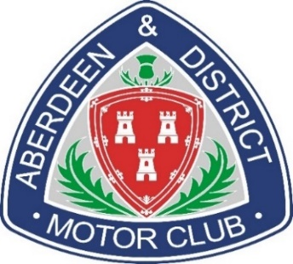
The Aberdeen & District Motor Club Ltd
2024 Membership Application Form

Data Protection:
The Aberdeen & District Motor Club Ltd (the “Club”) will use the personal information you provide on this Membership Application Form for the purposes of administration and for contacting you by mail, telephone and e-mail about the Club’s activities, events and new developments related to it. I hereby release and grant to the Club, their assigns, licensees, and legal representatives, the right to use any photographs of me taken by the Photographer, in all forms and media, whether now existing or not yet created, and in all manners for promotional, charitable and educational purposes in connection with the club. I hereby waive any right to inspect or approve the finished versions, including written copy that may be created in connection therewith. I have read this RELEASE AND CONSENT and am fully familiar with its contents. By signing this Membership Application Form, you consent to the Club to processing the information you provide on it for the purposes described above.

Signed:……………………………………………………………………….Date:………………………………..

Single Membership £20.00 ** Family Membership £25.00
**The below application form should be completed for each family member.
ALL Family Members must reside at the SAME ADDRESS.

Payment preferably by BACS:
Please use your name (as shown on this form) as reference.

Santander Sort Code: 09-01-50 Account Number: 03227960
Account Name: Aberdeen & District Motor Club
Cheques accepted if necessary payable to: Aberdeen & District Motor Club Ltd.
Your completed application forms should preferably be emailed to:
ADMC-membership@outlook.com
Or by snail mail to:
ADMC Membership Secretary, 2 Glenhead Lodges, Kemnay, Inverurie AB51 5PR
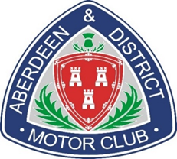
The Aberdeen & District Motor Club Ltd
2024 Membership Application Form

Please ensure you complete a separate form for each family member.

Name:

Address:

Post Code:

Telephone Number: Home
Mobile

Email:

Date of Birth (if under 21):

I am interested in the following areas of Motorsport (please tick)

Competing Organising Marshalling

